Vauxhall Gyratory Proposals – TfL Request to Screen Out the need for an EIA - 17/00562/EIASCR
Representation on behalf of the Kennington, Oval and Vauxhall Forum (KOVF)
1 This is a representation on behalf of KOVF, the body designated for neighbourhood planning purposes to produce a Neighbourhood Plan for the KOV area. We ask that this urban development project, dealing with an area notorious for its adverse air quality in a dense urban setting, should be subject to a full EIA, and not be screened out.

The Screening Decision
2 We proceed on the basis that this is an urban development project with an area exceeding 1 ha, thereby constituting a Schedule 2 development for the purposes of the Town and Country Planning (Environmental Impact Assessment) Regulations 2011, SI 2011 No 1824. We also take it that it falls to Lambeth as the planning authority to make a screening decision having regard to the criteria set out in Schedule 3 to those regulations.

3 In that regard we argue that the proposals should be screened in for a full EIA, on the basis of the following criteria:
- Para 1(e) – scale of pollution and nuisance, even after the mitigation to the existing dire situation claimed by TfL
- Para 2(vi) – the area concerned grossly breaches EU standards for air quality, in particular NOx, as revealed by this image of modelled annual average NOx

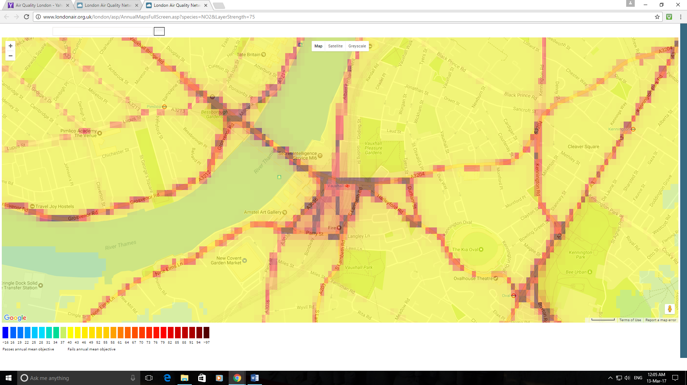

- Para 2(vii) – density of population, with the four surrounding LSOAs having a population of 7977 (mid 2013 est) in an area of 62.4 ha, a density of 127.8 persons per hectare (St George Wharf, LSOA 004G actually runs up to 375 persons per hectare). This is high by any standards, even that of Lambeth as a whole of 121 persons per hectare (mid 2015 est).
- Paras 3(a), (d), and (e) – the extent, probability and irreversibility of the proposals

4 It is no answer to say that the proposal mitigates the existing dire situation if what is provided is merely grievous. We need an Environmental Statement to identify the options that have been considered, and their respective environmental impacts, to see if any have better impact on air quality or reduce it to EU compliant levels. It is also to be noted that the modelled responses in the TfL abbreviated assessment of air quality impacts do not model the changes, if any, in the area highlighted as new public open space. Any such designation is problematic if the air quality there would merit warning notices to the effect that “Loitering in this area can seriously damage your health”!

Request to Mayor of London
5 I am copying this representation to the Mayor of London with the request that he say if, under the various Mayor of London Orders, he shares with the Secretary of State the power (under Regulation 4(3) of the 2011 Regulations) to direct an EIA even if Lambeth do not.

David Boardman
Chair
Planning Group
Kennington Oval and Vauxhall Forum
21 March 2017

